TCGA-PAAD: PIP5K1A Correlation with available 30 genes
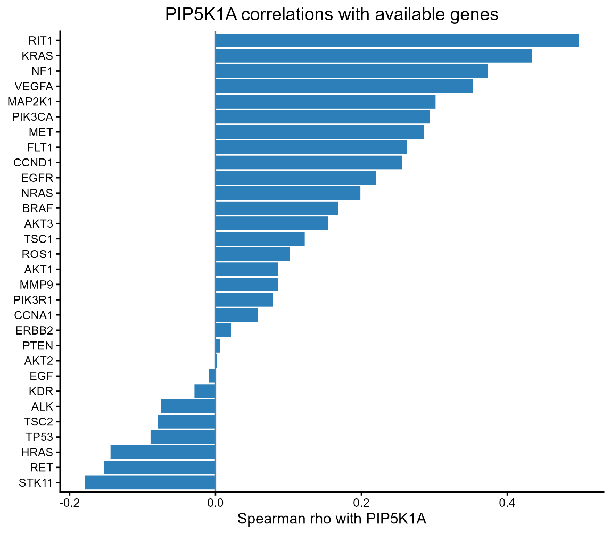
Correlation study was carried out using Spearman’s correlation test on 30 genes against PIP5K1A. The data was normalized and variance stabilizing transformation was done for validity. 8 genes showed negative correlation with PIP5K1A, while the remaining 22 genes showed positive correlation. The results were consistent with previous findings, validating them.
The summarized table with the exact rho value, as well as the p value is shown below. Individual correlation plots for each gene can be seen at the very end of the document.
Summary table

gene | rho | p.value
RIT1 | 0.498186 | 0
KRAS | 0.433948 | 1.37E-09
NF1 | 0.373651 | 2.53E-07
VEGFA | 0.353152 | 1.19E-06
MAP2K1 | 0.30159 | 3.82E-05
PIK3CA | 0.293735 | 6.15E-05
MET | 0.285451 | 0.0001
FLT1 | 0.262419 | 0.000361
CCND1 | 0.255964 | 0.000507
EGFR | 0.220145 | 0.00288
NRAS | 0.198886 | 0.007194
STK11 | -0.17919 | 0.015605
BRAF | 0.168056 | 0.023448
AKT3 | 0.153977 | 0.038043
RET | -0.15294 | 0.039371
HRAS | -0.1441 | 0.05236
TSC1 | 0.122296 | 0.100009
ROS1 | 0.10208 | 0.170302
TP53 | -0.08927 | 0.230528
AKT1 | 0.085747 | 0.249498
MMP9 | 0.08553 | 0.250702
TSC2 | -0.07866 | 0.290869
PIK3R1 | 0.07804 | 0.294728
ALK | -0.0749 | 0.314972
CCNA1 | 0.057602 | 0.439527
KDR | -0.0289 | 0.698325
ERBB2 | 0.021286 | 0.775271
EGF | -0.00912 | 0.902792
PTEN | 0.006094 | 0.934871
AKT2 | 0.001908 | 0.979596

